|  |
| --- |
| Khulna University of Engineering and Technology,khulna-9203 |
| ATM Machine Software Unit Test |
| Software testing final project |
|  |
| **Delowar Sikder 1607094** |
| **6/29/2021** |

|  |
| --- |
|  |

Table of Contents

1. Introduction 1

1.1 Purpose 1

1.2 Background 1

1.3 Definition 1

1.4 Reference 1

2. Test Overview 2

2.1 Test Object 2

2.2 Test Time 2

2.3 Test Methods 2

2.4 Test Constraint 3

2.5 Testers 3

3. Test Environment 3

3.1 Test Hardware Environment 3

3.2 Test Software Environment 3

4. Test Situation 4

4.1 Test Content 4

4.2 Test Completion Situation 10

5. Test Result and Analysis 10

5.1 Login 11

5.1.1 Login Instructions 11

5.1.2 Data Constraints 11

5.1.3 Invalid Test Cases 12

5.1.4 Valid Test Cases 14

5.2 Create Account 15

5.2.1 Create Account Instructions 15

5.2.2 Data Constraints 15

5.2.3 Invalid Test Cases 19

5.2.4 Valid Test Cases 21

5.3 Pin Change 21

5.3.1 Account Pin Change Instructions 21

5.3.2 Data Constraints 21

5.3.3 Valid Test Cases 22

5.4 Balance Inquiry 24

5.5.1 Balance Inquiry Instructions 24

5.5.2 Data Constraints 25

5.5.3 Valid Test Cases 25

5.5 Deposit 26

5.6.1 Deposit Instructions 26

5.6.2 Data Constraints 26

5.6.3 Invalid Test Cases 27

5.6.4 Valid Test Cases 28

5.6 Withdraw 29

5.7.1 Withdraw Instructions 29

5.7.2 Data Constraints 31

5.7.3 Invalid Test Cases 31

5.7.4 Valid Test Cases 32

5.7 Transfer 33

5.8.1 Transfer Instructions 33

5.8.2 Data Constraints 36

5.8.3 Invalid Test Cases 36

5.8.4 Valid Test Cases 37

6. Evaluation 38

# Introduction

## Purpose

Throughout writing this report, I tell that my audience clearly all the components of this software (ATM Machine) is develop by well qualified developer .Who have a huge knowledge about java programming language and swing framework. It is full perfect ATM Machine software report this test report is a document that records data obtained from the test, describes the environmental or operating conditions, and shows the comparison of test results with test objectives.

## Background

This document is the software test report of ATM Machine software development project designed By ‘Delowar Sikder’. It contains the results of tests, which were executed during the testing.

1. Definition

PIN:

Personal Identification Number.

Accounts No:

List of Registered account through this software.

Account Detail:

Using this software you need to enter your account detail for transaction and send money to another person your account detail is safe using this software.

* 1. Reference

The internet

[1] White Box Testing, Software Testing Fundamentals, accessed 29 May 2020, <http://softwaretestingfundamentals.com/white-box-testing/>

[2] Jain, Mahak, GeeksforGeeks, accessed 29 May 2020, <https://www.geeksforgeeks.org/differences-between-black-box-testing-vs-white-box-testing/>

# Test Overview

## Test Object

The test object for the unit testing is a simple ATM Machine application. Made and designed using IntelliJ IDEA Community Edition 2020.3 version software in Java language with 16.0.1 jdk version, Swing Framework and it uses MS access database as the databases that has access using UcanAccess Driver.

## Test Time

The tests are performed from May 30th through June 15st of 2021.

## Test Methods

The method used in this test is called the white box testing (also known as Clear Box Testing, Open Box Testing, Glass Box Testing, Transparent Box Testing, Code-Based Testing or Structural Testing). This method is named so because in the eyes of the tester, the software program is like a white/transparent box, where one can see clearly, what is inside.

White box testing is a software testing method in which the internal structure/design/implementation of the item being tested is known to the tester [2]. The tester, usually a developer as well, chooses inputs to traverse the paths of the code and determines the appropriate outputs. Knowledge of programming and implementation is essential. White box testing is testing beyond the user interface and into the practical details of a system.

One of the advantage of using white box testing is the test is more comprehensive and can cover most paths. However, because the testing can be very complex, it requires highly skilled resources, sufficient programming, and implementation knowledge.

Definition by ISTQB (International Software Testing Qualifications Board):

* White-box testing: Testing based on an analysis of the internal structure of the component or system.
* White-box test design technique: Procedure to derive and/or select test cases based on an analysis of the internal structure of a component or system. [1]

## Test Constraint

The overall test constraints for this test are listed below:

1. The test report is based on the tested software version.
2. All tests are based on the same test environment as the development environment (including the operating system, database, etc.);

## Testers

The tester is also the author of this document and the developer of this project.

# Test Environment

## Test Hardware Environment

|  |  |  |  |  |  |
| --- | --- | --- | --- | --- | --- |
| Test Environment | Device | Processor | System Type | Memory | External Storage |
| Host development environment | Laptop computer | Intel CORE i5  7th Generation | Windows-10,64-bit Operating System, x64-based processor | 12GB | None |

## Test Software Environment

|  |  |
| --- | --- |
| Software | Product Name |
| Operating System | Windows 10 Pro |
| Programming Language | Java |
| Software Development Environment | java 16.0.1 2021-04-20  Java(TM) SE Runtime Environment (build 16.0.1+9-24)  Java HotSpot(TM) 64-Bit Server VM (build 16.0.1+9-24, mixed mode, sharing)Java HotSpot(TM) 64-Bit Server VM (build 25.241-b07, mixed mode) |
| Database | MSAccess-2016 |

# Test Situation

## Test Content

The test is mainly carried out to check the functional feature using the application interface. The test mostly analyses the three interfaces which is the login window (login function), Registration window (create account) and Account Query window where you can choose (Deposit, Balance Inquiry, pin change, Withdraw, Transfer Balance and Logout) functionality.

See table 3 for the login test cases. See table 4.1, table 4.2, table 4.3, and table 4.4 for the tests executed on the window. See table 4.5, table 4.6, table 4.7, table 4.2.1 for the tests performed on the customer’s window.

The table below lists the test cases on the login window:

Table 4.1 Login test cases

|  |  |  |  |
| --- | --- | --- | --- |
| Test Case ID | Test Content | Execution times | Test Results |
| Log-0 | Login with an empty account number and PIN field | 5 | Achieve the expected result |
| Log-1 | Login with an empty account number field | 5 | Achieve the expected result |
| Log-2 | Login with an empty PIN field | 5 | Achieve the expected result |
| Log-3 | Login with a non-existent account number in the database | 5 | Achieve the expected result |
| Log-4 | Login with a non-existent account number (the inputted account number is a number) in the database | 5 | Achieve the expected result |
| Log-5 | Login with an existing account number in the database and a wrong PIN | 5 | Achieve the expected result |
| Log-6 | Login with an existing account number in the database and its corresponding PIN | 5 | Achieve the expected result |
| Log-7 | Click on the account number field | 5 | Achieve the expected result |
| Log-8 | Click on the PIN field | 5 | Achieve the expected result |

List of fields in the window:

1. Account no
2. Name
3. PIN
4. Confirm PIN
5. Date of Birth
6. Cash Deposit

The table below lists the test cases for making a new customer account on the clerk’s window (create account tab):

Table 1.2 Create account test cases

|  |  |  |  |
| --- | --- | --- | --- |
| Test Case ID | Test Content | Execution times | Test Results |
| CrtAcc-0 | Attempt to create a new account without inputting anything on all the fields (all the fields listed above are empty) | 5 | Achieve the expected result |
| CrtAcc-1 | Attempt to create a new account with an invalid PIN (not a 6-digit number), and let all the other fields empty | 5 | Achieve the expected result |
| CrtAcc-2 | Attempt to create a new account with a valid PIN (a 6-digit number), and let all the other fields empty | 5 | Achieve the expected result |
| CrtAcc-3 | Attempt to create a new account with a valid PIN (a 6-digit number), confirm PIN doesn’t match the PIN, and let all the other fields empty | 5 | Achieve the expected result |
| CrtAcc-4 | Attempt to create a new account with a valid PIN (a 6-digit number), confirm PIN matches the PIN, and let all the other fields empty | 5 | Achieve the expected result |
| CrtAcc-5 | Attempt to create a new account with a valid PIN (a 6-digit number), confirm PIN matches the PIN, invalid name (with symbol or number), and let all the other fields empty | 5 | Achieve the expected result |

The table below lists the test cases for pin change of a customer account on the pin window:

Table 4.3 pin change of account test cases

|  |  |  |  |
| --- | --- | --- | --- |
| Test Case ID | Test Content | Execution times | Test Results |
| PinChangeAacc-0 | Enter Wrong pin | 10 | Achieve the expected result |
| PinChangeAacc-1 | Enter Wrong Account no | 3 | Achieve the expected result |
| PinChangeAacc-2 | Enter invalid password | 3 | Achieve the expected result |
| PinChangeAacc-3 | Test with new pin and confirm new pin | 3 | Achieve the expected result |

The table below lists the test cases on the window (balance inquiry tab): Table 4.4 Balance inquiry test cases

|  |  |  |  |
| --- | --- | --- | --- |
| Test Case ID | Test Content | Execution times | Test Results |
| BalInq-0 | Click the balance inquiry tab after login | 5 | Achieve the expected result |
| BalInq-1 | Click the balance inquiry tab after depositing | 3 | Achieve the expected result |
| BalInq-2 | Click the balance inquiry tab after withdrawing | 3 | Achieve the expected result |
| BalInq-3 | Click the balance inquiry tab after transferring | 3 | Achieve the expected result |

The table below lists the test cases on the window (deposit tab):

Table 4.5 Deposit test cases

|  |  |  |  |
| --- | --- | --- | --- |
| Test Case ID | Test Content | Execution times | Test Results |
| Dep-0 | Click the deposit tab after login | 5 | Achieve the expected result |
| Dep-1 | Click the deposit tab after withdrawing | 3 | Achieve the expected result |
| Dep-2 | Click the deposit tab after transferring | 3 | Achieve the expected result |
| Dep-3 | Deposit some amount of money into the account | 3 | Achieve the expected result |
| Dep-4 | Attempt to deposit with an invalid amount (not a positive number which is greater than 0) | 3 | Achieve the expected result |

The table below lists the test cases on the window (withdraw tab):

Table 4.6 Withdraw test cases

|  |  |  |  |
| --- | --- | --- | --- |
| Test Case ID | Test Content | Execution times | Test Results |
| WD-0 | Click the withdraw tab after login | 5 | Achieve the expected result |
| WD-1 | Click the withdraw tab after depositing | 3 | Achieve the expected result |
| WD-2 | Click the withdraw tab after transferring | 3 | Achieve the expected result |
| WD-3 | Withdraw some amount of money from the account | 3 | Achieve the expected result |
| WD-4 | Attempt to withdraw with an invalid amount (not a positive number which is greater than 0) | 3 | Achieve the expected result |
| WD-5 | Attempt to withdraw with an amount greater than the balance (exception for credit account, as long as the balance after withdrawal is greater and equal to 0 – the credit line) | 3 | Achieve the expected result |

The table below lists the test cases on the window (transfer tab):

Table 4.7 Transfer test cases

PS: Login using a credit account will not show the transfer tab.

|  |  |  |  |
| --- | --- | --- | --- |
| Test Case ID | Test Content | Execution times | Test Results |
| Trans-0 | Click the transfer tab after login | 5 | Achieve the expected result |
| Trans-1 | Click the transfer tab after depositing | 3 | Achieve the expected result |
| Trans-2 | Click the transfer tab after withdrawing | 3 | Achieve the expected result |
| Trans-3 | Transfer some amount of money to an existing target account, with a description | 3 | Achieve the expected result |
| Trans-4 | Transfer some amount of money to an existing target account, without any description | 3 | Achieve the expected result |

## Test Completion Situation

Table 4.2.1 Test completion

|  |  |  |
| --- | --- | --- |
| Test Task Name | Content | Progress (% Complete) |
| Test plans, writing test case | Find resources for the different formats used to display | 100% |
| Prepare test data and environment | See test cases | 100% |
| Execute function test, fill up test data | See test cases | 100% |
| Sort out test data, writing test report | Sorting out test data to write test report | 100% |

# Test Result and Analysis

The test cases written in the previous chapter are used to test functions of the software/system/application. It is divided into three sub-functions, which are login, registration, and account query window functions, and each sub-function is analysed in detail according to the test results.

## Login

### Login Instructions

When the application is run, the login window will come into view. There is no specific user type. Here design a special purpose software for basic login, registration and others features. To login, the account number and PIN must be filled correctly. The PIN is hidden by default. Other option you will see as registration name. A new user can easily registration using ATM Machine software.

### Data Constraints

. If one of the situations listed below occur, a warning window will appear:

* The account number is not in the database (Figure 2)
* The account number and password combination is not correct (Figure 4)
* The account number field is empty (Figure 3)
* The PIN field is empty (Figure 3)
* Account is found (Figure 5)

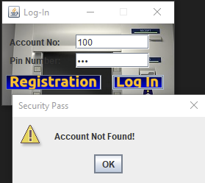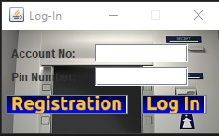

Fig-5.1: Initial window

Fig-5.2: Account not found

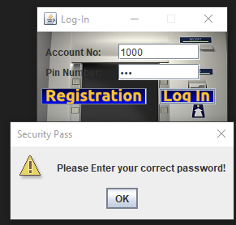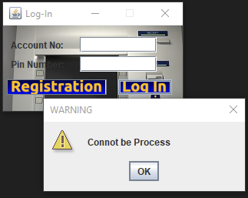Fig-5.3: Field Empty Fig-5.4: Wrong password

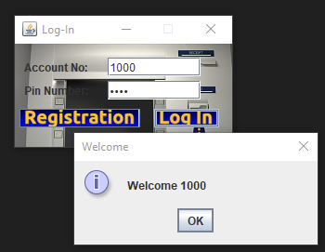

Fig-5.5: Successfully Login

### Invalid Test Cases

List of valid account number and its PIN in the database:

* Account number: 100000000 PIN: 100000000

1. Empty account number and PIN field

|  |  |  |  |
| --- | --- | --- | --- |
| **Account Number Input** | **PIN Input** | **Output** | **Expected Result** |
|  |  | Warning window (Figure 3) | Warning window (Figure 3) |

Table 5.1 Empty account number and PIN

1. Empty Account or PIN Field

|  |  |  |  |
| --- | --- | --- | --- |
| **Account Number Input** | **PIN Input** | **Output** | **Expected Result** |
|  | 123456 | Warning window (Figure 3) | Warning window (Figure 3) |
| 100000000 |  | Warning window (Figure 3) | Warning window (Figure 3) |
|  | 13456 | Warning window (Figure 3) | Warning window (Figure 3) |
| 100000001 |  | Warning window (Figure 3) | Warning window (Figure 3) |

Table 5.2 Account number or PIN field (one of them)

1. Non-existent account number (and the inputted account number is not a number)

|  |  |  |  |
| --- | --- | --- | --- |
| **Account Number Input** | **PIN Input** | **Output** | **Expected Result** |
| qwerty | 123456 | Warning window (Figure 2) | Warning window (Figure 2) |
| asdfgh | 98765 | Warning window (Figure 2) | Warning window (Figure 2) |

Table 5.3 Invalid account number

1. Non-existent account number (the inputted account number is a number)

|  |  |  |  |
| --- | --- | --- | --- |
| **Account Number Input** | **PIN Input** | **Output** | **Expected Result** |
| 100000001 | 123456 | Warning window (Figure 2) | Warning window (Figure 2) |
| 100000002 | 123456 | Warning window (Figure 2) | Warning window (Figure 2) |

Table 5.4 Non-existing account number

1. Login with an existing account with the wrong PIN

|  |  |  |  |
| --- | --- | --- | --- |
| **Account Number Input** | **PIN Input** | **Output** | **Expected Result** |
| 100000000 | 3456 | Warning window (Figure 4) | Warning window (Figure 4) |
| 100000000 | 654321 | Warning window (Figure 4) | Warning window (Figure 4) |

Table 5.5 Existing account with the wrong PIN

### Valid Test Cases

* 1. Valid account number and its corresponding PIN

|  |  |  |  |
| --- | --- | --- | --- |
| **Account Number Input** | **PIN Input** | **Output** | **Expected Result** |
| 1000000 | 123456 | window (Figure 4) | window (Figure 4) |

Table 5.6 Valid account number and its corresponding PIN

## Create Account

### Create Account Instructions

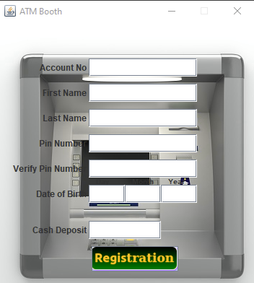When you run application, you will see two option. Login others is registration. If you want to registration, click the registration button. Then you will move to registration panel. To create account all fields must be filled valid, and then click the “Registration” button on the lower bottom part of the window. If a new account is successfully created, an info window will appear and it will mention the account number of the account that has just been created.

Figure 5.6: Registration panel

### Data Constraints

To create a new a new account successfully all the conditions below must be met, if not a warning window will appear:

1. All fields must not be empty
2. Insert Unique Account and password
3. PIN must be a 6-digit number
4. Confirm PIN must matches the PIN
5. Name can’t have any numeric digits or symbol
6. Interest rate fields (if the account type chosen is a saving account), credit line fields (if the account type chosen is a credit account), transaction fee fields (if the account type chosen is a checking account). All three fields are considered must be a number.
7. Use the valid date as a birthdate
8. Deposit must be a number

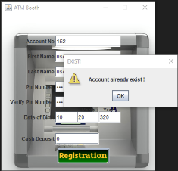

Figure- 5.7: Account Already Exist

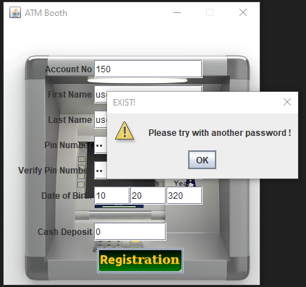

Figure 5.8: Need Unique Password

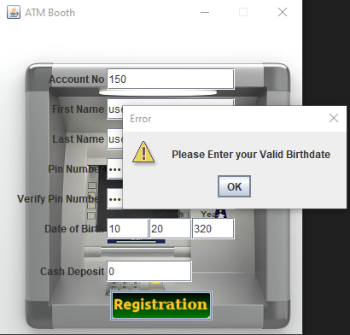

Figure 5.9: Birthdate Validation

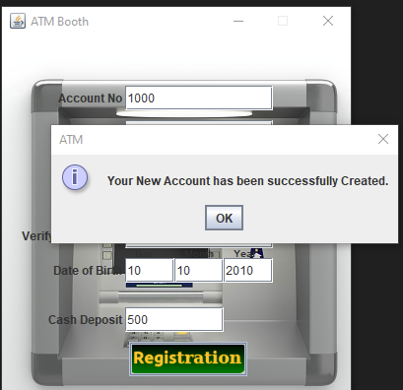

Figure 5.10: Account Successfully created

### Invalid Test Cases

* 1. All fields are empty (except account type because saving account is the default)

|  |  |  |  |
| --- | --- | --- | --- |
| **Field** | **Input** | **Output** | **Expected Output** |
| **Account NO** |  | Warning window | Warning window |
| **PIN** |  |
| **Confirm PIN** |  |
| **First Name** |  |
| **Last name** |  |
| **Date of birth** |  |
| **Deposit** |  |

Table 5.7 All fields empty (Create account tab)

* 1. At least one of the fields is empty (not including the account type because saving account is the default)

|  |  |  |  |
| --- | --- | --- | --- |
| **Field** | **Input** | **Output** | **Expected Output** |
| **PIN** | 098733 | Warning window | Warning window |
| **Confirm PIN** |  |
| **Name** |  |
| **Account Type** | Saving Account |
| **Interest rate, credit line, or transaction fee** |  |
| **Deposit** |  |

Table 5.2 Empty confirm PIN

|  |  |  |  |
| --- | --- | --- | --- |
| **Field** | **Input** | **Output** | **Expected Output** |
| **PIN** | 123456 | Warning window | Warning window |
| **Confirm PIN** | 123456 |
| **Name** |  |
| **Account Type** | Saving Account |
| **Interest rate, credit line, or transaction fee** |  |
| **Deposit** |  |

Table 5.8 Empty name

|  |  |  |  |
| --- | --- | --- | --- |
| **Field** | **Input** | **Output** | **Expected Output** |
| **PIN** | 123456 | Warning window | Warning window depends on the account type, in this case |
| **Confirm PIN** | 123456 |
| **Name** | Alpha |
| **Account Type** | Saving Account |
| **Interest rate, credit line, or transaction fee** |  |
| **Deposit** |  |

Table 5.9 Empty deposit

* 1. Invalid PIN

|  |  |  |  |
| --- | --- | --- | --- |
| **Field** | **Input** | **Output** | **Expected Output** |
| **PIN** | hello | Warning window | Warning window |
| **Confirm PIN** | 123456 |
| **Name** | Alpha |
| **Account Type** | Saving Account |
| **Interest rate, credit line, or transaction fee** | 1.2 |
| **Deposit** | 1000 |

Table 5.10 Invalid PIN

* 1. Confirm PIN doesn’t match

|  |  |  |  |
| --- | --- | --- | --- |
| **Field** | **Input** | **Output** | **Expected Output** |
| **PIN** | 123456 | Warning window | Warning window |
| **Confirm PIN** | 123455 |
| **Name** | Alpha |
| **Account Type** | Saving Account |
| **Interest rate, credit line, or transaction fee** | 1.2 |
| **Deposit** | 1000 |

Table 5.11 Confirm PIN mismatch

* 1. Invalid deposit

|  |  |  |  |
| --- | --- | --- | --- |
| **Field** | **Input** | **Output** | **Expected Output** |
| **PIN** | 123456 | Warning window | Warning window |
| **Confirm PIN** | 123456 |
| **Name** | Alpha |
| **Account Type** | Saving Account |
| **Interest rate, credit line, or transaction fee** | 1.2 |
| **Deposit** | One thousand |

Table 5.12 Invalid deposit

### Valid Test Cases

1. Create a new account with all fields filled and valid

|  |  |  |  |
| --- | --- | --- | --- |
| **Field** | **Input** | **Output** | **Expected Output** |
| **PIN** | 123456 | Info window of a new account created with the account number | Info window of a new account created with the account number |
| **Confirm PIN** | 123456 |
| **Name** | Alpha |
| **Account Type** | Saving Account |
| **Interest rate,** | 1.2 |
| **Deposit** | 1390 |

Table 5.13 Create new account (Alpha)

|  |  |  |  |
| --- | --- | --- | --- |
| **Field** | **Input** | **Output** | **Expected Output** |
| **PIN** | 123456 | Info window of a new account created with the account number | Info window of a new account created with the account number |
| **Confirm PIN** | 123456 |
| **Name** | Beta |
| **Account Type** | Credit Account |
| **Credit line** | 1000 |
| **Deposit** | 874 |

Table 5.14 Create new account (Beta)

## Pin Change

### Account Pin Change Instructions

After login in your account using this system, you will able to see some Balance Query option .where you can pick option as your require .Pin change is a one of them. Which privilege you to change your account pin no.

### Data Constraints

If one of the situations listed below occur, a warning window will appear:

1. Account no
2. Current pin no
3. New Pin no
4. Confirm current pin

All constrain must be followed otherwise, you get warning and pin number no change at all.

### Valid Test Cases

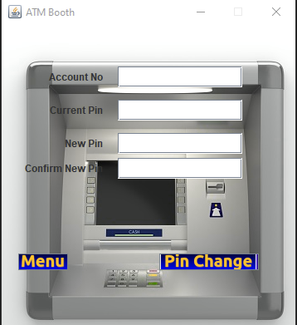

Figure-5.11: Pin Change Window

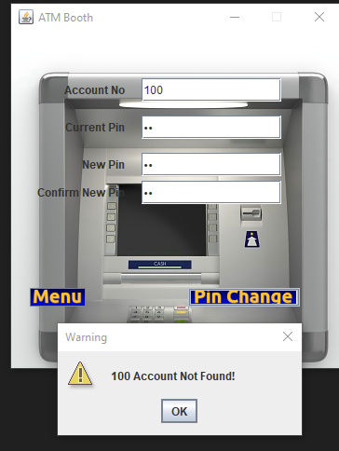Figure-5.12: Account Validation

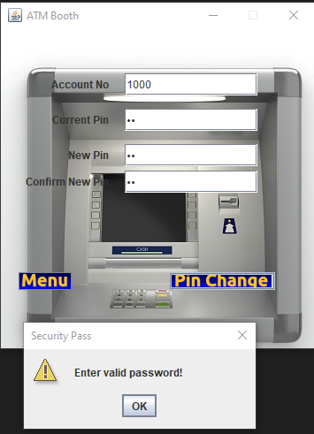

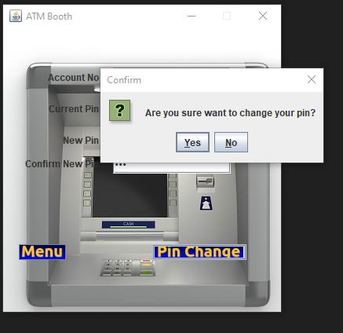 Figure -5.13: Current password not match

Figure -5.14: Confirmation of a PIN Change

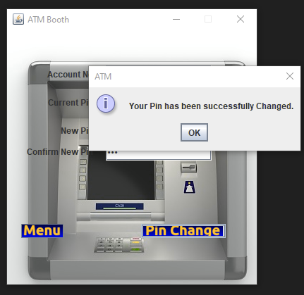

Figure -5.15: Pin has been changed

## Balance Inquiry

### Balance Inquiry Instructions

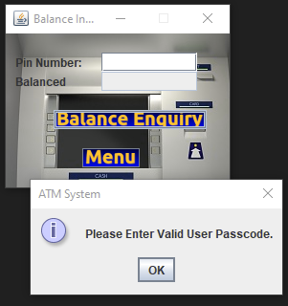After login using a customer’s account, the customer’s window will come into view. Balance inquiry tab is the first tab in the customer’s window. Balance inquiry tab just gives information about the current balance of the current account number (account number that is used to log in).

Figure-5.16: Check valid user and passcode

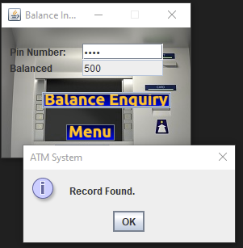

Figure-5.17: Balance Inquiry Successful

### Data Constraints

No input is needed. It just shows the current balance of the account. The balance should change if the user deposits, withdraws, or transfers (transfer function is not available for credit account) some amount of money.

### Valid Test Cases

* 1. After login

|  |  |  |
| --- | --- | --- |
| **Account Number** | **Output** | **Expected Output** |
| 100000001 | 800 | 800 |
| 100000002 | 1000 | 1000 |
| 100000003 | 1400 | 1400 |
| 100000004 | 800 | 800 |
| 100000005 | 1100 | 1100 |

Table 5.15 Balance inquiry after login

* 1. After depositing

|  |  |  |  |  |
| --- | --- | --- | --- | --- |
| **Account Number** | **Balance Before Deposit** | **Deposit Amount** | **Output** | **Expected Output** |
| 100000001 | 800 | 200 | 1000 | 1000 |
| 100000002 | 1000 | 500 | 1500 | 1500 |
| 100000003 | 1400 | 100 | 1500 | 1500 |

Table 5.16 Balance inquiry after deposit

* 1. After withdrawal

|  |  |  |  |  |
| --- | --- | --- | --- | --- |
| **Account Number** | **Balance Before Withdrawal** | **Withdraw Amount** | **Output** | **Expected Output** |
| 100000001 | 1000 | 100 | 900 | 900 |
| 100000002 | 1500 | 200 | 1300 | 1300 |
| 100000003 | 1500 | 300 | 1200 | 1200 |

Table 5.17 Balance inquiry after withdrawal

* 1. After transferring (excluding credit account)

|  |  |  |  |  |
| --- | --- | --- | --- | --- |
| **Account Number** | **Balance Before Transfer** | **Transfer Amount** | **Output** | **Expected Output** |
| 100000001 | 900 | 100 | 800 | 800 |
| 100000003 | 1200 | 200 | 1000 | 1000 |
| 100000004 | 800 | 300 | 500 | 500 |

Table 5.18 Balance inquiry after transfer

## Deposit

### Deposit Instructions

After login using a customer’s account, the customer’s window will come into view. Deposit tab is the second tab in the customer’s window. To deposit the amount field must be filled with a valid amount. After that click on the deposit button or press enter from the amount field. A confirmation window will appear, click yes to deposit, click no, or close the confirmation window to cancel. If yes is clicked there will be an information window telling the amount has been successfully deposited.

### Data Constraints

The amount must be a positive number and greater than 0 (zero) to be considered a valid amount. Warning window will come out if any of the situations below are met:

* Empty amount field
* Amount field is not a number or contains non-numeric digit
* 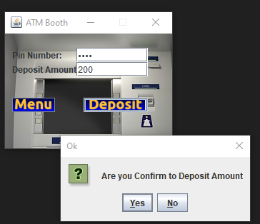

Figure 5.18: Deposit Confirmation

### Invalid Test Cases

* 1. Empty amount

|  |  |  |
| --- | --- | --- |
| **Amount Input** | **Output** | **Expected Output** |
|  | Warning window | Warning window |

Table 5.19 Deposit with an empty amount

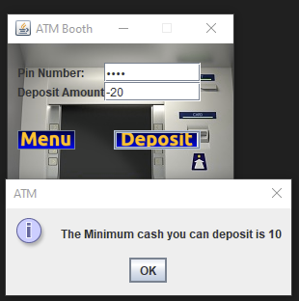

Figure-5.19: Minimum Account Check

* 1. Invalid amount

|  |  |  |
| --- | --- | --- |
| **Amount Input** | **Output** | **Expected Output** |
| hi | Warning window | Warning window |
| -100 | Warning window | Warning window |
| 30a | Warning window | Warning window |
| 0 | Warning window | Warning window |

Table 5.20 Deposit with an invalid amount

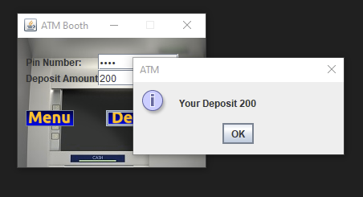

Figure-5.20: Deposit has been successful

### Valid Test Cases

1. After login

|  |  |
| --- | --- |
| **Output** | **Expected Output** |
| All information in deposit tab are correct | All information in deposit tab are correct |

Table 5.21 Information in deposit tab after login

1. After withdrawal

|  |  |
| --- | --- |
| **Output** | **Expected Output** |
| Balance information in deposit tab are updated | Balance information in deposit tab are updated |

Table 5.22 Information in deposit tab after withdrawal

1. After transfer (excluding credit account)

|  |  |
| --- | --- |
| **Output** | **Expected Output** |
| Balance information in deposit tab are updated | Balance information in deposit tab are updated |

Table 5.23 Information in deposit tab after transfer

1. Click enter after inputting the amount to deposit

|  |  |
| --- | --- |
| **Output** | **Expected Output** |
| Confirmation window | Confirmation window |

Table 5.24 Click enter after inputting valid amount

1. Deposit some amount of money into the account

|  |  |  |  |  |
| --- | --- | --- | --- | --- |
| **Account Number** | **Balance Before Deposit** | **Deposit Amount** | **Output** | **Expected Output** |
| 100000001 | 800 | 200 | Balance = 1000 | Balance = 1000 |
| 100000002 | 1000 | 500 | Balance = 1500 | Balance = 1500 |
| 100000003 | 1400 | 100 | Balance = 1500 | Balance = 1500 |

Table 5.25 Deposit

## Withdraw

### Withdraw Instructions

After login using a customer’s account, the customer’s window will come into view. Withdraw tab is the third tab in the customer’s window. To withdraw the amount field must be filled with a valid amount. After that click on the withdraw button or press enter from the amount field. A confirmation window will appear, click yes to withdraw or click no or close the confirmation window to cancel. If yes is clicked there will be an information window telling that the amount of money has been successfully withdrawn.

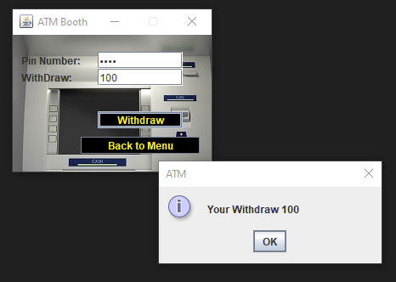

Firgure-5.21: Confirmation of withdraw

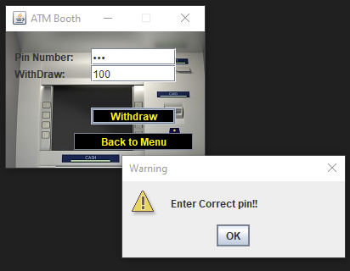

Figure-5.22: Pin validation

### Data Constraints

The amount must be a positive number and greater than 0 (zero) to be considered a valid amount. Warning window will come out if any of the situations below are met:

* Empty amount field
* Amount field is not a number or contains non-numeric digit (Figure 23)
* Amount is 0 (zero)
* Amount is greater than the current balance. Exception for credit account, as long as the balance after the withdrawal is greater and equal to 0-credit line you can still withdraw it. Balance can be minus only for credit account.

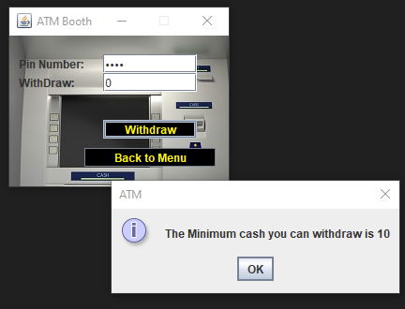

Firgure-5.23: Check minimum withdraw

Figure 27 Insufficient balance error windows

### Invalid Test Cases

* 1. Empty amount

|  |  |  |
| --- | --- | --- |
| **Amount Input** | **Output** | **Expected Output** |
|  | Warning window | Warning window |

Table 5.26 Withdraw with an empty amount

* 1. Invalid amount

|  |  |  |
| --- | --- | --- |
| **Amount Input** | **Output** | **Expected Output** |
| hello | Warning window | Warning window |
| -500 | Warning window | Warning window |
| A90 | Warning window | Warning window |
| 0 | Warning window | Warning window |

Table 5.27 Withdraw with an invalid amount

* 1. Insufficient balance

|  |  |  |  |  |
| --- | --- | --- | --- | --- |
| **Account type** | **Balance Before Withdrawal** | **Withdraw Amount** | **Output** | **Expected Output** |
| Saving Account | 800 | 801 | Error window | Error window |
| Checking Account | 1000 | 1500 | Error window | Error window |

Table 5.28 Insufficient balance

### Valid Test Cases

* 1. After login

|  |  |
| --- | --- |
| **Output** | **Expected Output** |
| All information in withdraw tab are correct | All information in withdraw tab are correct |

Table 5.29 Information in withdraw tab after login

* 1. After deposit

|  |  |
| --- | --- |
| **Output** | **Expected Output** |
| Balance information in withdraw tab are updated | Balance information in withdraw tab are updated |

Table 5.30 Information in withdraw tab after deposit

* 1. After transfer (excluding credit account)

|  |  |
| --- | --- |
| **Output** | **Expected Output** |
| Balance information in withdraw tab are updated | Balance information in withdraw tab are updated |

Table 5.31 Information in withdraw tab after transfer

* 1. Click enter after inputting the amount to be withdrawn

|  |  |
| --- | --- |
| **Output** | **Expected Output** |
| Confirmation window | Confirmation window |

Table 5.32 Click enter after inputting valid amount

* 1. Withdraw some amount of money from the account

|  |  |  |  |  |  |
| --- | --- | --- | --- | --- | --- |
| **Account Number** | **Account Type** | **Balance Before Withdrawal** | **Withdraw Amount** | **Output** | **Expected Output** |
| 100000001 | Saving Account | 1000 | 100 | Balance = 900 | Balance = 900 |
| 100000002 | Credit Account | 1500 | 200 | Balance = 1300 | Balance = 1300 |
| 100000002 | Credit Account | 1300 | 1700 | Balance = -400  (Credit line=1000) | Balance = -400  (Credit line=1000) |
| 100000003 | Checking Account | 1500 | 300 | Balance = 1200 | Balance = 1200 |

Table 5.33 Withdrawal

For credit account, the balance can be minus up to its credit line. For example, if the credit line is 1000, than means the balance can be up to -1000. So even if the withdraw amount is greater than the current balance the money can still be withdrawn.

## Transfer

### Transfer Instructions

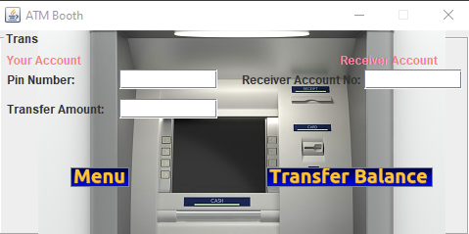After login using a customer’s account, the customer’s window will come into view. Transfer tab is the fourth tab in the customer’s window. This tab won’t appear if the account type of the customer is credit account. To transfer the amount field must be filled with a valid amount and the target account must be also a valid one. After filling the amount, target account, and description (optional) field, click on the transfer button. A confirmation window will appear (Figure 28), click yes to transfer or click no or close the confirmation window to cancel the transfer. If yes is clicked there will be an information window (Figure 29) telling that the amount of money has been successfully transferred to account number.

Figure-5.24: Transformation Window

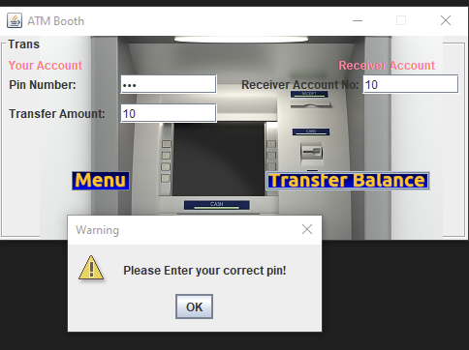

Figure5.25: Pin Validation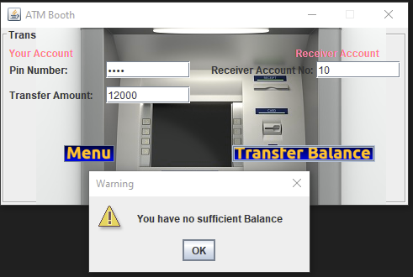

Figure-5.26: Balance Check

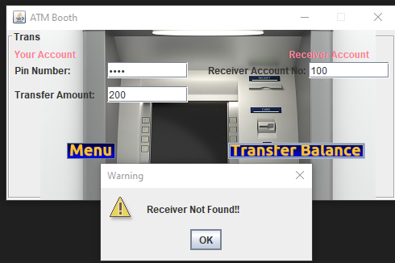

Figure-5.27: Receiver is exist or not

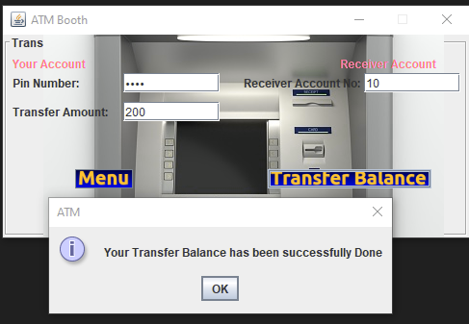

Figure-5.28 : Transformation is Done

### Data Constraints

The amount must be a positive number and greater than 0 (zero) to be considered a valid amount. Warning window will come out if any of the situations below are met:

* Empty amount field
* Empty target account field Amount field is not a number or contains non-numeric digit
* Amount is 0 (zero) Non-existing target account
* Target account refers to the current account

### Invalid Test Cases

* 1. Empty amount

|  |  |  |
| --- | --- | --- |
| **Amount Input** | **Output** | **Expected Output** |
|  | Warning window | Warning window |

Table 5.34 Empty transfer amount

* 1. Invalid amount

|  |  |  |
| --- | --- | --- |
| **Amount Input** | **Output** | **Expected Output** |
| hai | Warning window | Warning window |
| -250 | Warning window | Warning window |
| 90a | Warning window | Warning window |
| 0 | Warning window | Warning window |

Table 5.35 Transfer with an invalid amount

* 1. Insufficient balance

|  |  |  |  |  |
| --- | --- | --- | --- | --- |
| **Account type** | **Balance Before Transfer** | **Transfer Amount** | **Output** | **Expected Output** |
| Saving Account | 1000 | 1001 | Error window | Error window |
| Checking Account | 1000 | 1500 | Error window | Error window |

Table 5.36 Insufficient balance

### Valid Test Cases

* 1. After login

|  |  |
| --- | --- |
| **Output** | **Expected Output** |
| All information in transfer tab are correct | All information in transfer tab are correct |

Table 5.37 Information in transfer tab after login

* 1. After deposit

|  |  |
| --- | --- |
| **Output** | **Expected Output** |
| Balance information in transfer tab are updated | Balance information in transfer tab are updated |

Table 5.38 Information in withdraw tab after deposit

* 1. After withdrawal

|  |  |
| --- | --- |
| **Output** | **Expected Output** |
| Balance information in transfer tab are updated | Balance information in transfer tab are updated |

Table 5.39 Information in withdraw tab after transfer

* 1. Transfer

|  |  |  |  |  |  |
| --- | --- | --- | --- | --- | --- |
| **Account Number** | **Balance Before Transfer** | **Transfer Amount** | **Target Account** | **Output** | **Expected Output** |
| 100000001 | 900 | 100 | 100000005 | Balance = 800 | Balance = 800 |
| 100000003 | 1200 | 200 | 100000006 | Balance = 1000 | Balance = 1000 |
| 100000004 | 800 | 300 | 100000007 | Balance = 500 | Balance = 500 |

Table 5.40 Transfer

# Evaluation

The tests mentions in this document are performed from 29th May through 15st June of 2021 by the author of this document who is also both the tester and the developer of this project. Below are some of the summary of the project:

1. The software is a simple ATM Machine application. It is developed using IntelliJ IDE 2020.3 Community Edition Software, java language version 16.0.1, and MS Access DB as its database this database added using Ucan Access driver. Both the tester and the developer use Windows 10 pro as its 64-bit Operating System.

2. The software has complete functions. It provides functions such as login, create account, search accounts, deposit, withdraw, transfer, pin change and other functions. It is comprehensive, reliable, and an easy-to-use software.

3. It is easy to change the functions because they are relatively independent.

4. The system is reliable. It has clear permission restrictions for different users, accurate error, warning, or information prompts.

5. The operation is convenient and easy to comprehend. The interface of each function of the system is simple, the style is consistent and the layout is convenient for users to use.

6. Based on the tests that are performed, all the output of the tests achieves the expected result.

Test result: passed